(Approx. 2,052 words)

Adobe Photoshop Elements 5
A Software Review by Nancy Dennis, Membership Chair, Sarasota PCUG, Florida
www.spcug.org
membership(at)spcug.org

Adobe Photoshop Elements 5 is a photo editing and organizing program that also includes easy to use features to backup your photos, and really fun creative ways to show off your photos to family and friends.

Adobe Photoshop is the top of the line photo program for the professionals and costs hundreds of dollars. Elements (under $100) has many of the same features as the professional version with a lot of fun and easy features added in, making it the software choice for the non-professional user like you and me.

The software installs the Adobe Photo Downloader in your system tray and is ready instantly whenever you plug in your camera or memory card. Your photos are downloaded into the Organizer where you have easy access to them for viewing, tagging, creating collections, printing, emailing, creating all the fun projects, or switching to the Edit mode for a Quick Fix or Full Edit. Your photos are identified by Elements in Catalogs. You can have multiple catalogs for different users of your computer in the family, or say for photos that you may use for work which you want to keep separate from home photos. You can even use the Organizer to select photos to order prints online or size and send through your email client. Your photos are managed by date with a timeline across the top of the screen that is very easy to navigate when you are looking for a photo at a specific time on the calendar. The Tags and Collections feature takes a few extra minutes when you first download the photos, but sure makes it easier to select certain photos when you are ready to create a project. Tags can be given for photos of specific family, friends or places and events. Collections work in a similar fashion but could include several different people, say in a vacation.

Since software packages come with little or no manuals, I find that one of my first places to explore is the Help feature. The Adobe Help Center, which is on the Help menu, includes a very extensive index of help on the program as well as hyperlinks to video tutorials on the Adobe web site. The Help Center includes a very good Search tool with easy navigation and even a Bookmark feature where you can bookmark a topic that you may want to return to again quickly. I was also offered free online tutorials from Adobe after I registered the software. Be sure to take advantage of this offer. There are eleven video tutorials that give a very good overview of everything from getting your photos into Elements to creating fun creative projects. Another quick way to get to help on any of the tools on the screen is to hover your mouse over the tool and a link appears that takes you directly to the Help Center on that tool. You will find that you don’t miss the manual with this complete Adobe Help Center.

When the Elements program starts there is a Welcome Screen where you can choose to open the Organizer, Quickly Fix Photos, Edit and Enhance Photos, or Make Photo Creations. Once you decide which mode you want to begin with you can set the Welcome Screen to always open in that mode or stay with the Welcome Screen. Since you need to open a photo in order to edit it or select several photos for projects it made sense to me to always open in the Organizer mode.

With a right click of a photo in the Organizer you can select the Go to Quick Fix feature as a truly “quick fix”. With this feature you are able to fix the most common problems with your photos without having to know any of the more advanced features. Now mind you the advanced features are in Elements, but you may find that you seldom need to go into that mode to get the results that you want. With Quick Fix mode you have auto buttons for lighting, color, sharpen and red eye. Then if the auto button doesn’t quite get the photo like you want there are fine tuning levers to adjust to finish the job. If you just can’t get the look you want you can click the Full Edit tab from this window and go into the more fully featured mode of Elements to complete the task.

Some of the new features for editing in Elements include correct lens distortion, sharpen blurred edges, fine-tuning with curves, creating dramatic black and whites and support for raw files. One of my very favorite features of Elements in the Full Edit mode is the Artwork and Effects Palette. From this palette you can pick from dozens of backgrounds, frames, graphics and shapes. Then select a style for that object from a dozen more selections and just drag and drop onto your photo. This palette includes different themes for effects, filters for effects and text styles, all applied with a double click. There is even a Favorites area where you can drag an effect that you especially liked and want to get back to quickly. A couple other favorites of mine in the Full Edit mode are the Adjust Color for Skin Tone and the Spot Healing Brush. If you have a photo where the skin color just doesn’t look right you can use the Adjust Color for Skin Tone feature to quickly change the skin tone by using the eyedropper over the skin. If you want the result a little more tan or blush there are easy adjustments in that same dialog box. The Spot Healing Brush works wonders for those marks and blemishes just by clicking over the area. There is also a new feature called Magic Extractor that provides an easy wizard to extract an object (or person) from your photo. Again there are fine tuning options in this wizard if the extraction is not quite what you want. I found that this features works very well. The red eye fix in Elements 5 is by far the best red eye fix that I have used in a photo editing program. There is even an option to have red eye corrected as your photos are being downloaded from the card reader.

Elements 5 has added a Back-Up and Restore feature that allows you to back up your photo catalogs to a server online (you have to sign up for this service). The online back up service through Adobe Photoshop Services gives you a 30 day free trial. There is also a Back-Up feature that will do Full and Incremental back ups of your catalogs to a CD or DVD, another drive, or another folder on the hard drive. This feature is Wizard driven and makes this very important task quick and easy, without leaving the Elements software. This feature is right there on the tool bar along with all the other online services.

Once you have your photos downloaded, edited and backed up it is time for the really fun part of Elements 5 – creating projects like photo book pages, photo layouts, album pages, greeting cards, CD and DVD jackets and labels, slide shows, VCD’s with menus, photo galleries and flipbooks for the web, photo calendars, and PhotoStamps. Most of the print projects can be printed on your own printer or ordered through an online service that can be set up with a wizard right in Elements. I didn’t register for the online service but was very tempted by some of the neat projects that can be created and then sent off for printing and delivery. For instance the photo calendar can be created with 12 of your photos and then step through the wizard to choose the cover, page layout, and title, etc. Then through the wizard the calendars will be printed, bound and mailed – what a great idea for Christmas gifts!

I decided to create a slide show with photos taken at Disney World. After selecting the photos from the Organizer and then selecting Slideshow from the Create menu the wizard started with slide show preferences and then the main Slideshow Editor opens with very full featured options that are available in most of the stand alone slide show programs. This feature is like a program within a program – I am really impressed with the scope of the Slideshow Editor. There are transition options, panning and zooming, audio and narration, and adding blank sides and graphics and text.

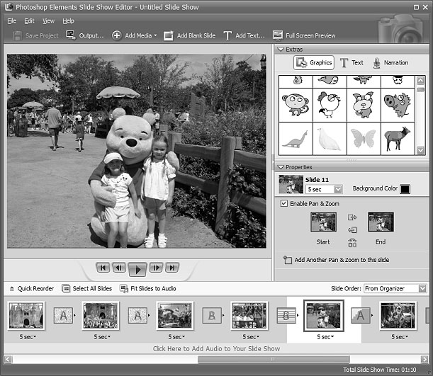
Once you have the show the way you like it the Output feature opens another wizard for options to save the show as a file, burn to disc, e-mail the show or send to a TV. The wizard works great burning to a Video CD format. (The only option that I would like to see added would be to burn to DVD.) If you have several slide shows that you would like to burn to one CD you can select the Create a VCD with menu and the wizard will allow you to add multiple slideshows and then create a menu before burning.
The next project I tried was to create a Photo Gallery. With the same Disney photos selected the Photo Gallery opens a wizard with three types of galleries; Web Galleries, Animated or Interactive. With Web Galleries chosen the wizard asks for arrangement of the photos on the page and a style with both options showing thumbnails of how your choice will look. Next the wizard opens a dialog window with more options to customize, such as Gallery Title and Slideshow duration and effects. You then can select where to Share the gallery; either choose Do Not Share (which saves to your hard drive), Photoshop Showcase (more about this later), My FTP Site, or CD. I also tried the Animated and Interactive galleries with the same photos. The wizard makes creating these very complex shows a breeze. If you don’t know how to publish to your web space a dialog box offers simple steps to help with that task, or you can register and sign on to the free Adobe Photoshop Elements Showcase feature. This is an online community for users of Elements to upload and share their photos and galleries.

Each project that you create and save is added to the Organizer at the top. If you want to edit a project you just double-click the project file and the wizard that was used to create it opens. All of the print projects like the Photo Book Pages, Photo Layouts and Album Pages, are saved (with multiple pages when applicable) with a .pse extension. The print projects are wizard driven and offer step by step selections for size, layout, theme and then additional options depending on the project chosen. I decided to make a print project of a CD cover and label for the Disney slide show that I created earlier. The wizard walked me through the entire process opening Elements in the Full Edit mode with my selected photo and all the layers in the layer palette created – it truly seemed like magic. Since you are left in this mode you can then adjust or fine tune the project before saving and printing it.

One feature that I was not able to try but may be of interest to some reading this review is the ability to download and upload photos from a mobile phone.

I highly recommend Adobe Photoshop Elements 5. There is an upgrade rebate in the box of $20, so if you are using an older version you can take advantage of that. The price today at Amazon.com is $69.99 with free shipping and your $20 rebate makes the total price $49.99. There are other special offers at local stores and online. Visit Adobe’s web page www.adobe.com for system requirements.

This article may be published only by APCUG member user groups. All other uses are prohibited. When used, APCUG must be acknowledged as the source and the author credited. The Editorial Committee of the Association of Personal Computer User Groups (APCUG), an international organization of which this group is a member, brings this article to you.

